43.8: a) 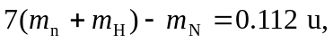 which is 105 MeV, or 7.48 MeV per nucleon.
b) Similarly, nucleon, slightly lower (compare to Fig. (43.2)).

